H.T No
Regulations:
A15

Sreenidhi Institute of Science and Technology
(An Autonomous Institution)
Code No: 5E517 Date: 17-August-2024 (AN)

B.Tech III-Year I- Semester External Examination, August - 2024 (Supplementary)
Theory of Computation (CSE and IT)

Time: 3 Hours Max.Marks:75 Note: a) No additional answer sheets will be provided.
b) All sub-parts of a question must be answered at one place only, otherwise it will not be valued.
c) Missing data can be assumed suitably.

Bloom's Cognitive Levels of Learning (BCLL)
Remember | L1 | Apply | L3 | Evaluate | L5
Understand | L2 | Analyze | L4 | Create | L6

Part - A Max.Marks:25

Answer all QUESTIONS.
 |  | BCLL | CO(s) | Marks
1 | Define Alphabet, Strings, Language and give an example to each one. | L1 | CO1 | [2M]
2 | Compare DFA and NFA. | L2 | CO2 | [2M]
3 | List closure properties of regular sets. | L1 | CO3 | [2M]
4 | State pumping lemma for Context Free Languages (CFG). | L2 | CO4 | [2M]
5 | Differentiate between recursive and recursively enumerable languages? | L2 | CO5 | [2M]
6 | Define P, NP problems with an example. | L1 | CO6 | [3M]
7 | Compare Moore and Melay Machines. | L2 | CO1 | [3M]
8 | Define Regular language and Regular Expression and give an example. | L1 | CO4 | [3M]
9 | What is church hypothesis? | L1 | CO5 | [3M]
10 | Why normal forms are important? When a grammar is said to be in Chomsky normal form? | L3 | CO2 | [3M]

Part – B Max.Marks:50
ANSWER ANY FIVE QUESTIONS. EACH QUESTION CARRIES 10 MARKS.

 |  |  | BCLL | CO(s) | Marks
11. | a) | Design DFA that accepts all the strings containing even numbers of 0’s & odd number of 1’s. | L5 | CO1 | [5M]
 | b) | Design DFA that accepts all the strings 0’s & 1’s over ∑= {0,1} ending with “100” | L5 | CO1 | [5M]
12. | a) | Design Moore machine to find the residue mod 4 for each binary string treated as binary integer? | L3 | CO2 | [5M]
 | b) | How to minimize Finite state machine? Explain with an example. | L3 | CO2 | [5M]
13. | a) | Explain Pumping Lemma for regular sets? Check whether the given language is regular or not {L=a^{n}b^{n} | n>=1} | L3 | CO3 | [5M]
 | b) | Construct Left Linear Grammar for the given Right Linear Grammar.  S-->aA  A-->bA/a/b | L6 | CO3 | [5M]
14. | a) | Define GNF and Reduce the following grammar to GNF.  S --> AA | 0 A--> SS | 1 . | L4 | CO4 | [5M]
 | b) | Write about the enumeration of properties of CFL. | L5 | CO4 | [5M]
15. | a) | What is Turing Machine? Explain different types of Turing Machines? | L2 | CO5 | [5M]
 | b) | Design Turing machine to accept the language L={a^{n}b^{n} | n>0} | L4 | CO5 | [5M]
16. | a) | Explain the Chomsky Hierarchy of languages. | L2 | CO6 | [5M]
 | b) | Explain post correspondence problem and its undecidability? | L3 | CO6 | [5M]
17. | a) | What are the applications of automata theory? | L2 | CO1 | [4M]
 | b) | Find epsilon (ε) – closure for given Finite automata.  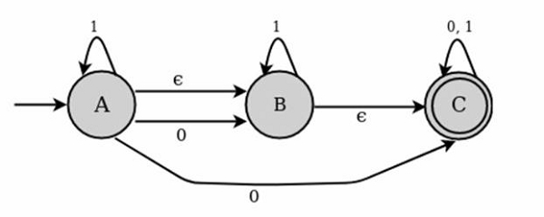 | L3 | CO2 | [3M]
 | c) | Design FA for the given Regular Expression R=(0+1)*00 | L4 | CO3 | [3M]
18. | a) | Explain the process of minimization of context free grammar. | L1 | CO4 | [4M]
 | b) | What is computable function? Give an example. | L1 | CO5 | [3M]
 | c) | What is Turing reducibility and why it is important? | L2 | CO6 | [3M]

-- 00 -- 00 –

